Care Cottages Application
Dashboard
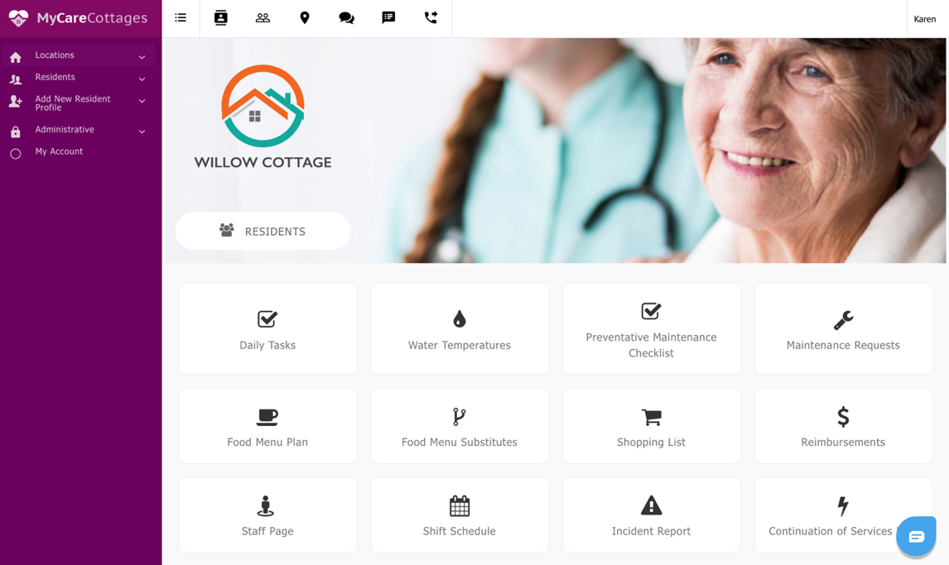

Descriptions:

Daily Tasks: Each day is broken into 3 shifts (7-3 pm) (3pm-11 pm) and (11 pm – 7am). Each shift has a list of daily cleaning tasks that must be completed (checklist) and stored as a document printable CSV file. These daily checklists must have the following: staff name who completed the document, date of the document and time stamp. These must be stored and available for at least 1 year in a database)

Water Temperatures: Each faucet and water source in the home must be measured for its hottest temperature once per month. Name of staff and date of measurement is a requirement. These must be storable in a database and accessible for 1 year minimum.

Preventative Maintenance Checklist: (Monthly List & Yearly List): This is a list of items that need to be checked monthly and yearly for preventative maintenance. If the checked item requires maintenance a Maintenance Request should be initiated. If item is in sufficient status the items are checked as sufficient and reports are stored (dated and time stamped).

Maintenance Requests: Each maintenance request requires a name attached, description, Level of urgency (urgent (1-12 hours), medium (1-3 days) low (1-3 weeks)
Client Dashboard

Features of the dashboard include the
- Resident’s name,
- rent amount,
- care amount
- grand total care costs
- name of the Next of Kin contact,
- Nok phone number and
- NoK email address
- edit button. (Button feature should show active or inactive status (deceased or moved).

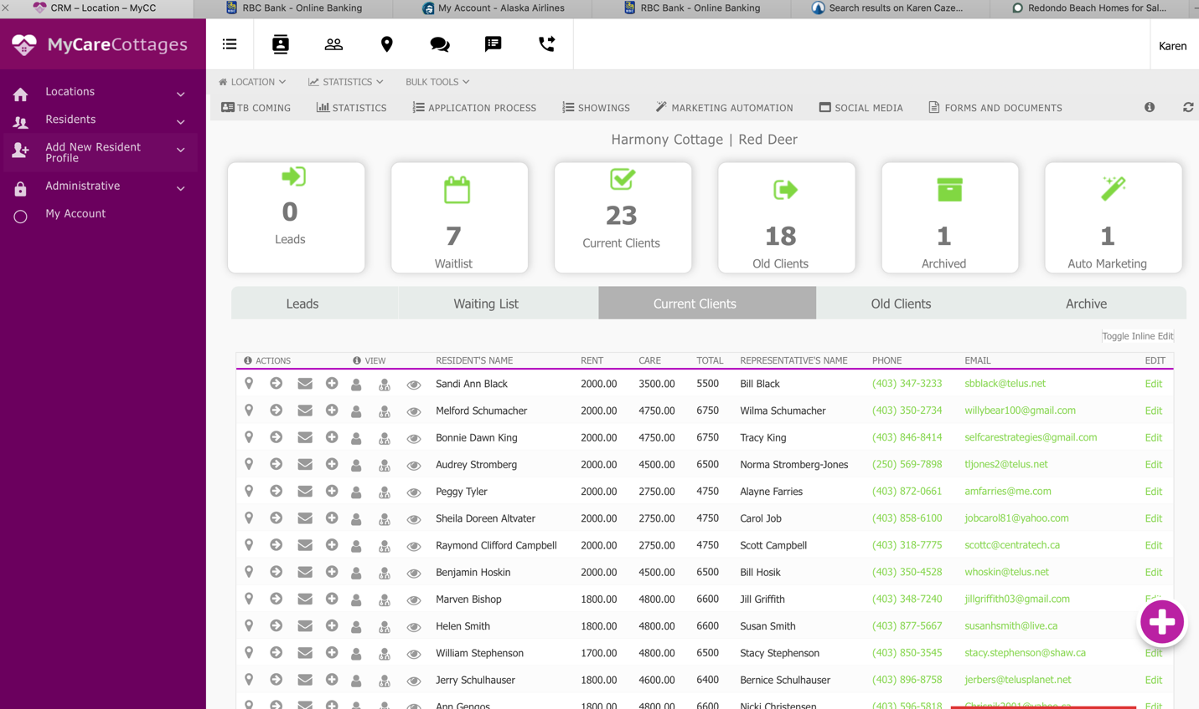

Leads: Someone calls or drops by the office… Name, phone number, email address (follow up radio button, yes/no, feedback column, date of follow up)

Waitlist: Full Application completed, $2000 deposit made, ready for move in (waitlist status)

Current Client: Full application and All signed documents available and visible

Old Client: Someone moved out. Not deceased.
Archived Client: Deceased client

Adding a New Client:
- Use the plus sign to add new resident
- Add a New Resident section on the left of the screen

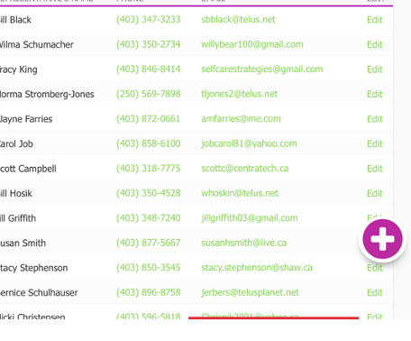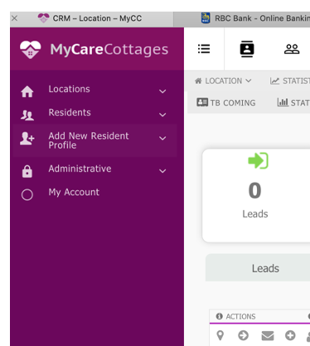

Create a New Resident:

- Use the plus sign
- Add resident’s name
- Next of Kin email address
- Next of Kin phone number
- Care and Rent Amounts

After profile is created…..

Click on the Resident and select one of the following steps….

- OPTION 1: Send the client an email to enroll in the online application process (using email from their profile, send them a link with the 4 step process.
  - Fill in the application
  - Sign the rent/care agreement
  - Sign the pharmacy consent
  - Supply banking details void cheque or online submission.
  - (option to message client personal message included here) see below image….
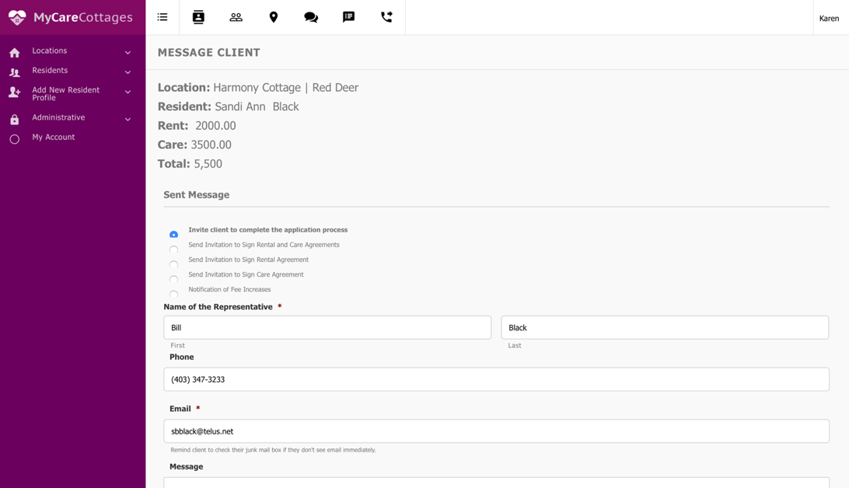

- OPTION 2: Fill out the application in the office with the family present using an ipad or computer.
  - Fill in the application (together verbally )
  - Sign the rent/care agreement (in the office using the ipad signature)
  - Sign the pharmacy consent (in the office using ipad digital signature)
  - Supply banking details void cheque or online submission.

Send Client Email… from the icon
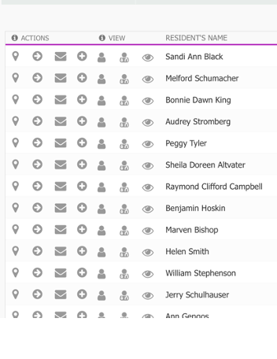
Add a New Client (plus sign or add information). Client’s Location Active Status Yes/No
In House Option to Fill out Presently….

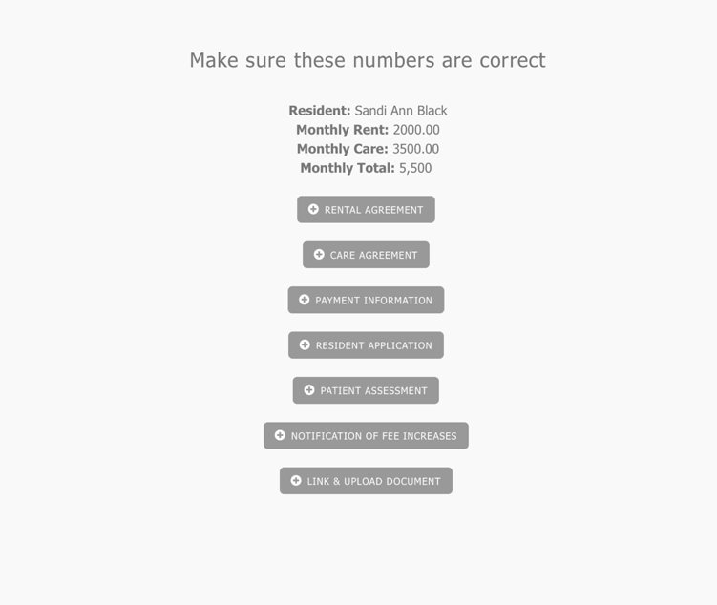

Chain of Events After Client Signs All Documents:
- After Application is signed and Submitted (email copy is sent to nurse, doctor, family and CEO
- After Care/Rent agreement is signed copy is sent to (family, CEO)
- After Financial information is submitted copy is sent to (bookkeeper and CEO)

Forms in Emails look like:

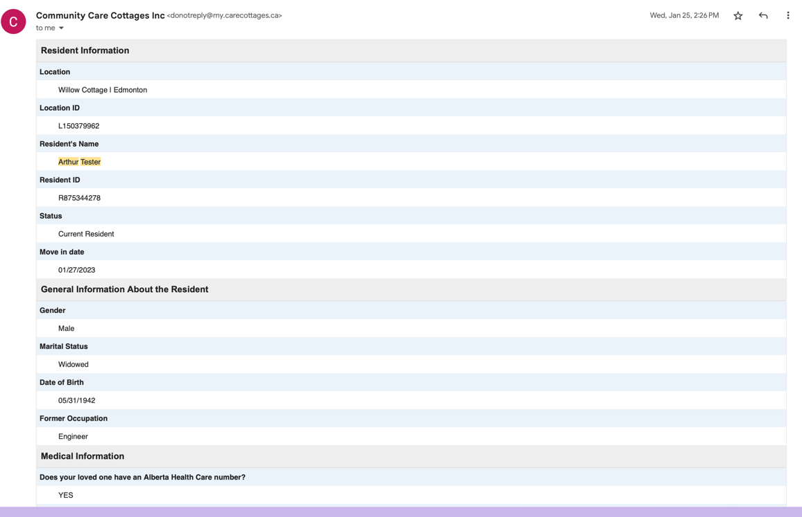

Resident Application Fields
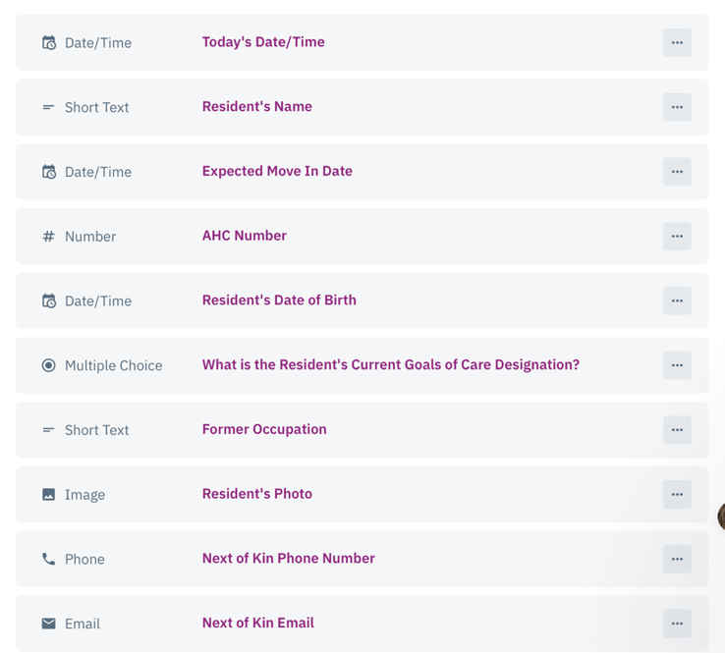
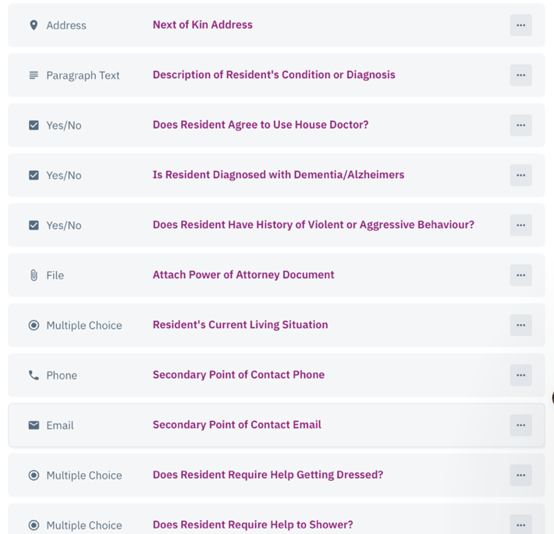
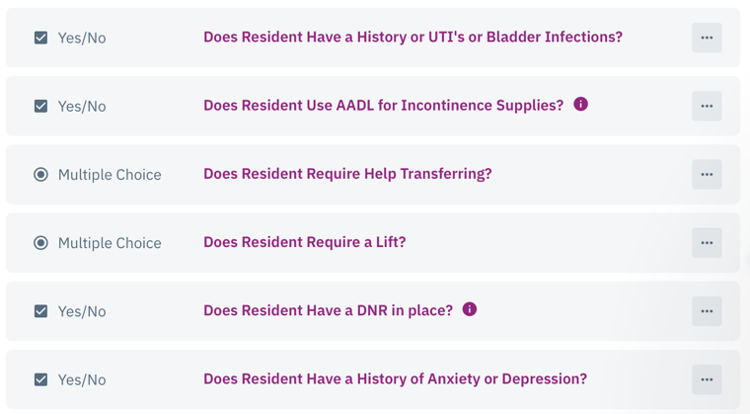

Resident Application Continued:
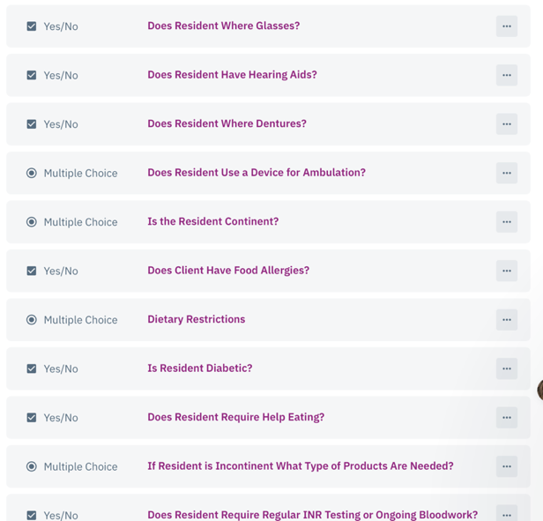

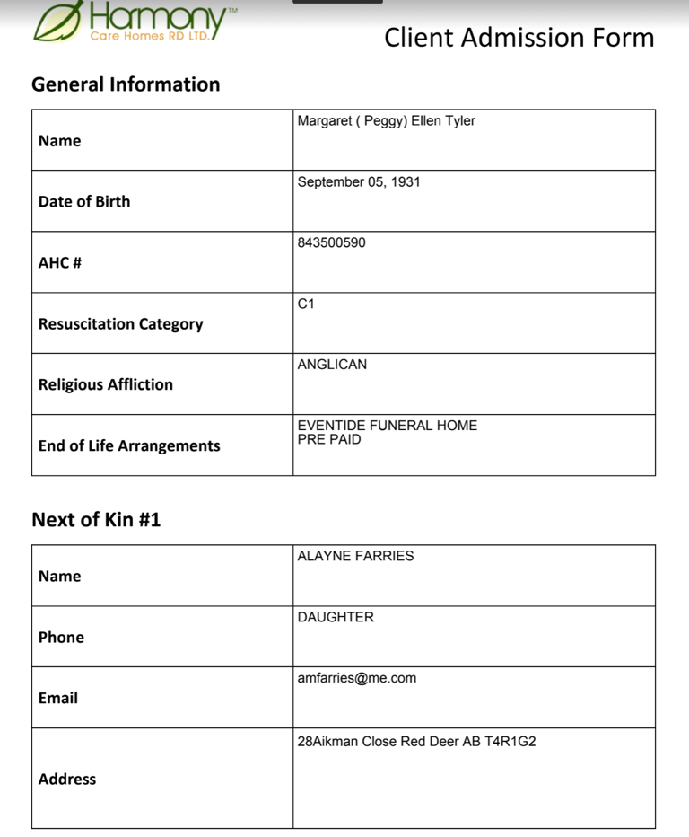
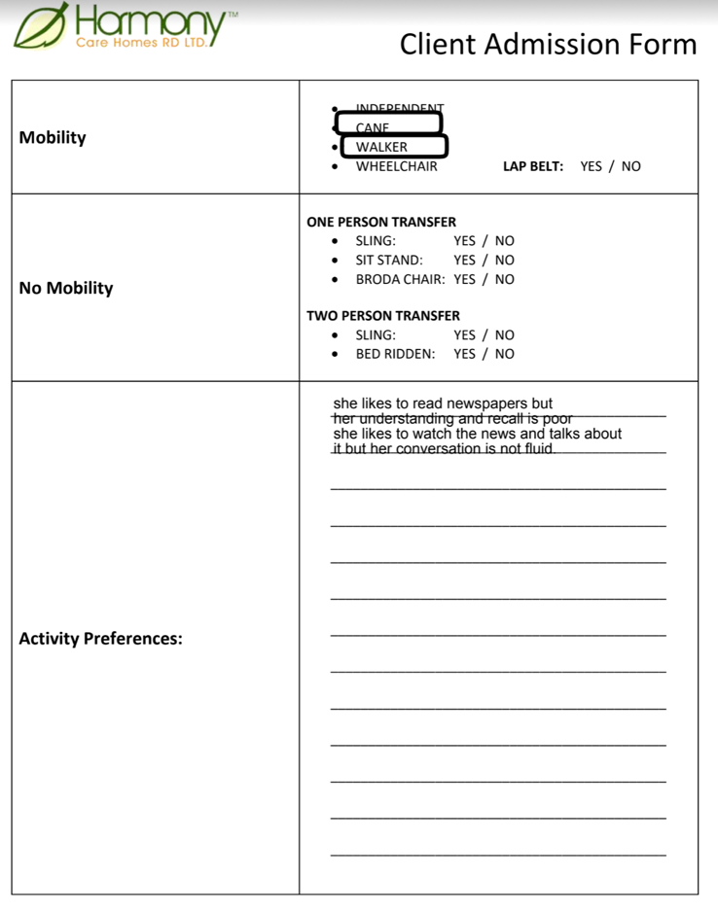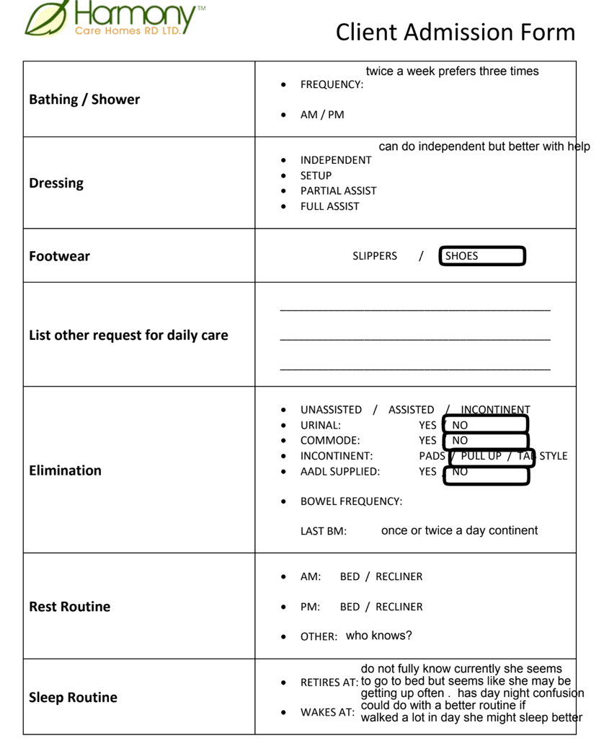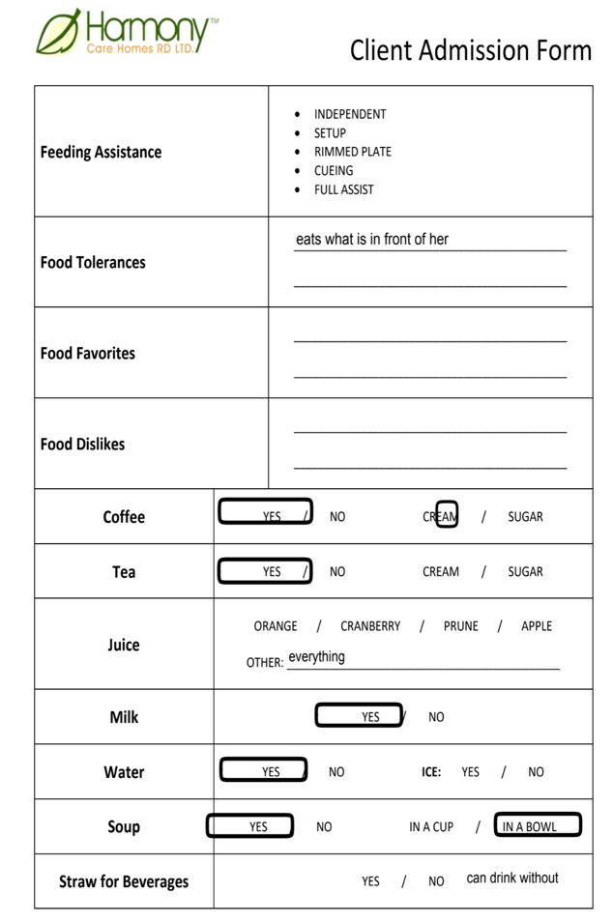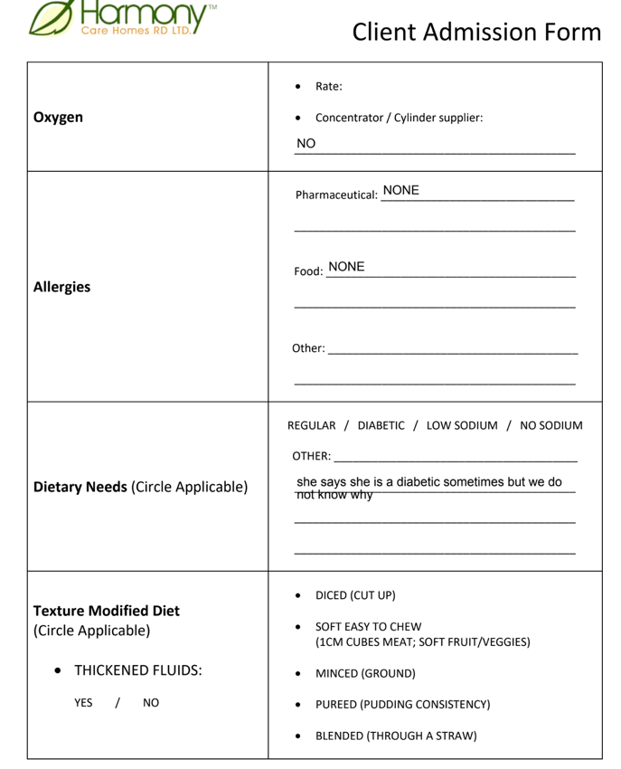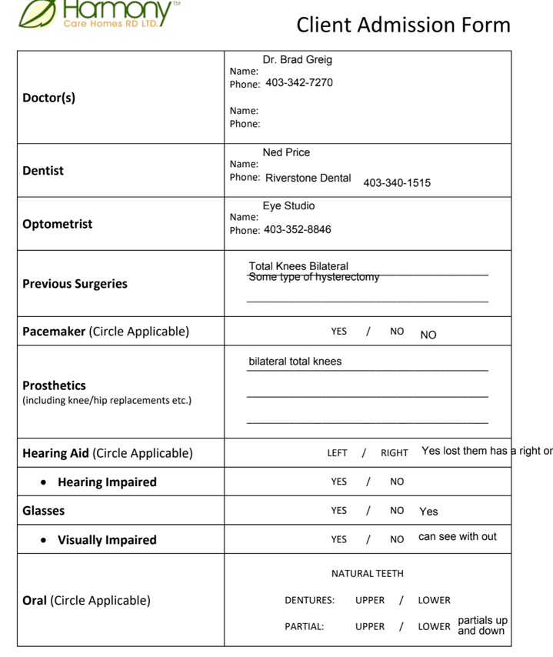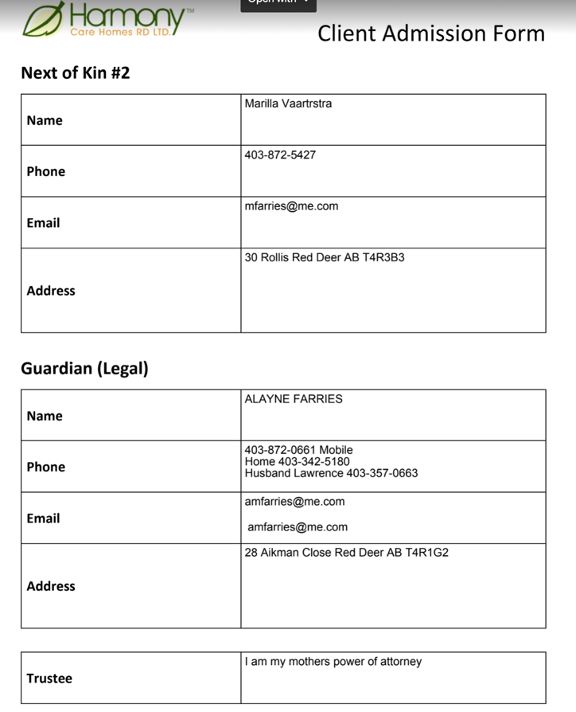

Resident Profiles:

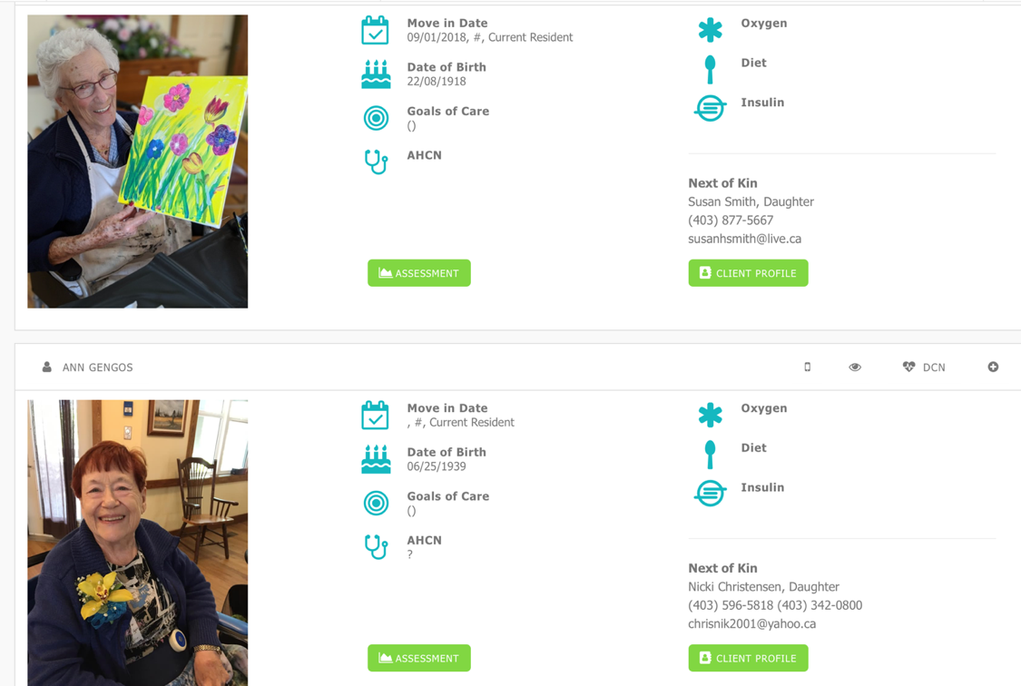

Staffing and HR Pages

High Level of Overview of this Section’s Capabilities (Summary of this Section Documentation)

- Upload Certifications
- Timesheet: Start and stop for each day. QR code or something if you like.

- Add a training module to be attached to each staff.

- Termination date or leave of absence request and ROE requests should also get sent to bookkeeping and payroll and managers.
- Is employee current Yes or No (search button)
- Add a small section for disciplinary actions or praise reports.

- Ability to transfer a staff to another cottage as needed.

- Ability for staff to request employment letters, change of address or change of bank details online.

- Include: Staff Scheduler Homebase

- Ability to archive old employees and access them as needed or disable their status etc.

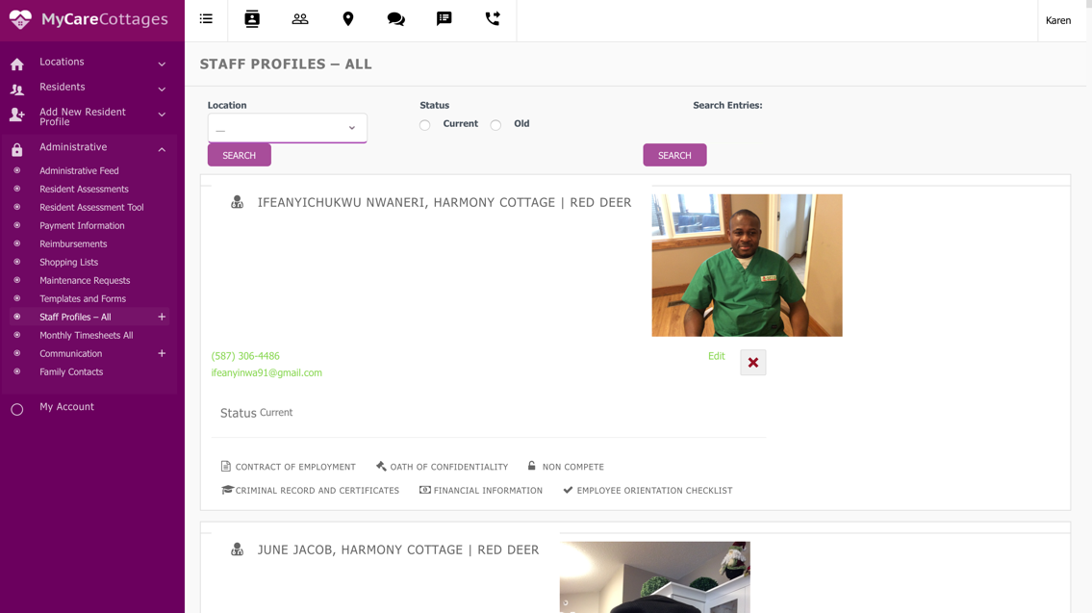

Page begins with Add New Staff Profile from within the Application
  - Invite new staff to join the application process send invite via email or text (QR Code?)
  - Staff Needs to be added to the Group WhatsApp Page
  - Staff Needs to be invited to the Homebase Scheduling Application
  - TimeSheet Capability logging daily start and stop times and total hours calculated daily running to a monthly total.
  - Signatures Needed and available online:
    - Oath of Confidentiality
    - Contract of Employment
    - Non-Compete
    - Criminal Record Check
    - Financial Void Cheque
    - Employee Orientation Checklist
We need all the application details filled out and sent to the new manager, payroll and bookkeeper.

A. General Information
1. Legal Last Name (Note: The word Legal is important as we hire primarily Filipinos and it isn’t always clear)
2. Legal First Name
3. Legal Middle Name
4. Preferred First Name
5. Title (Mr, Mrs, Miss, etc)
6. Sex
7. Date of Birth
8. Mailing Address
9. Email address
10. Cell phone number
11. Please attach a current photo

B. Work Information
1. SIN
2. Projected first day of work
3. Position (either HCA, Manager, Handyman, Bookkeeper, other)
4. Have you worked for Care Cottages previously Y/N. If yes, when did you leave and why?
[this is important because our payroll program archives all previous employees and it is
best to re-activate rather than create a new employee profile]
5. Please upload your resume
6. Please upload your certification related to your position
7. Please upload any training certificates that you have obtained

C. Bank Information – Note: you can get this information from your bank or from the bottom of your cheque

1. Transit #
2. Institution or Bank #
3. Account #

D. Tax Information – our payroll program will automatically gave you the basic personal tax exemptions. If you are deserving of additional exemptions, you will need to complete a TD1form for Alberta and Canada and submit it with your application. Those forms are found by clicking this link.

Office Only Section
- Training
- The Manager that is doing the hiring will train the new staff in the following areas. We need a check boxthat the Manager will check to note that the training has been completed.
  - On-boarding Orientation checklist
  - Fire Exit Escape training
  - Cleaning Licensing Procedures
  - Resident Care: Orientation Procedures
  - Food Handling
  - Hoyer Lifting
  - Staff Scheduling Policy

B. Start-up Information (provided by the Manager)
a. Starting Salary
b. Length of Probationary Period
c. Salary after the probationary Period

Sample of Timesheet information

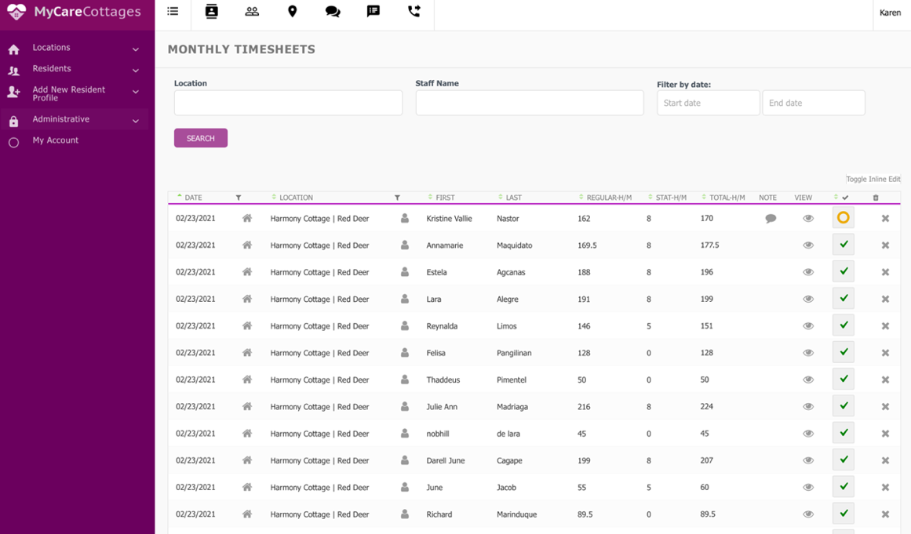

Re-Direct Shift Schedule to Homebase:

